(1. b. link)

Mobile makes a vital contribution to the
economy of Bangladesh

In addition to the contribution that the mobile sector will continue to make towards the attainment of Vision 2021 and the SDGs, it is important to consider how the mobile ecosystem in Bangladesh is already a vibrant contributor to the local economy. It consists of mobile network operators, infrastructure service providers, retailers and distributors of mobile products and services, handset manufacturers and mobile content, application and service providers.

In 2015, the mobile ecosystem generated 6.2% of GDP in Bangladesh, a contribution that amountedto around $13 billion of economic value added. This figure includes the direct economic impact of mobile operators and the broader ecosystem as well as the indirect impact and the productivity increase brought about by the use of mobile technologies.

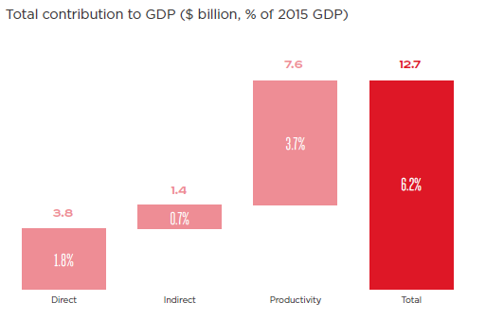

(Source: Country overview: Bangladesh: Mobile industry driving growth and enabling digital inclusion, 2018, by GSMA)

